**Language Execution Basics**

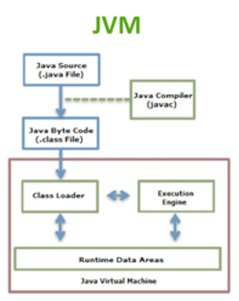

How JVM works:  
Java Language Source (Human code language)  
 - Converted to - > (Java Compiler)  
Java Byte Code (Middle-language)  
- Put into